**1.** What is software? What is software engineering?

* **Software**

Software is a set of instructions or programs that instruct a computer to perform specific tasks, encompassing various applications like operating systems, utility programs, user applications, and video games, and is a crucial component of modern computing.

* **Software engineering**

Software engineering is a systematic, disciplined approach to designing, developing, testing, and maintaining software systems, utilizing engineering principles to produce high-quality, reliable, and efficient systems using various methodologies, tools, and practices**.**

Software engineering involves understanding and documenting software requirements, creating a blueprint, implementing it, testing it, and maintaining it throughout its lifecycle. It emphasizes collaboration, project management, and best practices to create high-quality software that meets user needs and is long-term maintainable. It involves updating, enhancing, and fixing issues throughout the software's lifecycle.

1. Explain types of software

* **System softwere**

Operating Systems (OS) manage hardware resources, provide user interface, and support application software like Windows, macOS, and Linux, while Device Drivers facilitate communication between hardware devices.

* **Application Software**

Productivity Software: Aids in word processing, spreadsheet calculations, presentations.

Graphics Software: Creates and manipulates visual content.

Media Players: Plays audio and video files.

Web Browsers: Enables website access and interaction.

Games and Entertainment Software: Provides interactive and leisure activities.

* **Development Software**

Integrated Development Environments (IDEs): Tools for software development like Visual Studio and Eclipse.

Version Control Software: Manages source code changes like Git and SVN.

Database Management Systems (DBMS): Manages databases and facilitates interaction.

* **Network Software:**

Network Operating Systems: Facilitates communication and resource sharing within a network. Examples include Novell NetWare.

Firewall and Security Software: Protects systems from unauthorized access and malicious activities. Examples include Norton Antivirus, McAfee.

* **Embedded Software:**

Firmware: Software embedded into hardware devices to control their operation. Examples include firmware in printers, routers, and IoT devices.

* **Business Software:**

Enterprise Resource Planning (ERP): Manages business processes and resources. Examples include SAP, Oracle.

Customer Relationship Management (CRM): Manages interactions with customers. Examples include Salesforce, HubSpot.

* **Artificial Intelligence (AI) Software:**

Machine Learning Libraries and Frameworks: Supports the development of AI and machine learning models. Examples include TensorFlow, PyTorch.

These categories are not mutually exclusive, and many software applications may fall into multiple categories based on their functionality. Additionally, with the evolution of technology, new types of software continuously emerge.

3.What is SDLC? Explain each phase of SDLC

**Software Development Life Cycle (SDLC) Overview**

**• Requirements Gathering and Analysis:**

- Understand and document software requirements.

- Conduct interviews, surveys, and meetings with stakeholders.

- Collect and analyze user requirements.

- Define system's functional and non-functional requirements.

- Deliverables: Requirements document, functional specifications.

**• System Design:**

- Create a high-level system architecture.

- Define system architecture, including hardware and software components.

- Create detailed specifications for each module or component.

**• Implementation (Coding):**

- Translate design specifications into executable code.

- Write code for each module or component.

- Perform unit testing.

**• Testing:**

- Validate the software to meet requirements and functions correctly.

- Deliverables: Test cases, test plans, defect reports, verified software.

**• Deployment (or Implementation):**

- Release the software to users and deploy it in the production environment.

- Develop an implementation plan.

**• Maintenance and Support:**

- Ensure the ongoing functionality and performance of the software.

- Address user issues, make necessary updates and enhancements.

4.**What is DFD? Create a DFD diagram on Flipkart**

A Data Flow Diagram (DFD) is a visual representation of data flow within a system, used in systems analysis and design to illustrate how data moves through various processes and stores. For a complex system like Flipkart, creating a DFD involves multiple levels, starting with a context-level diagram and progressing to detailed diagrams for each subsystem. Due to the platform's complexity and proprietary nature, a simplified context-level DFD can be provided for an online shopping system.

**DFD for Online Shopping System:**

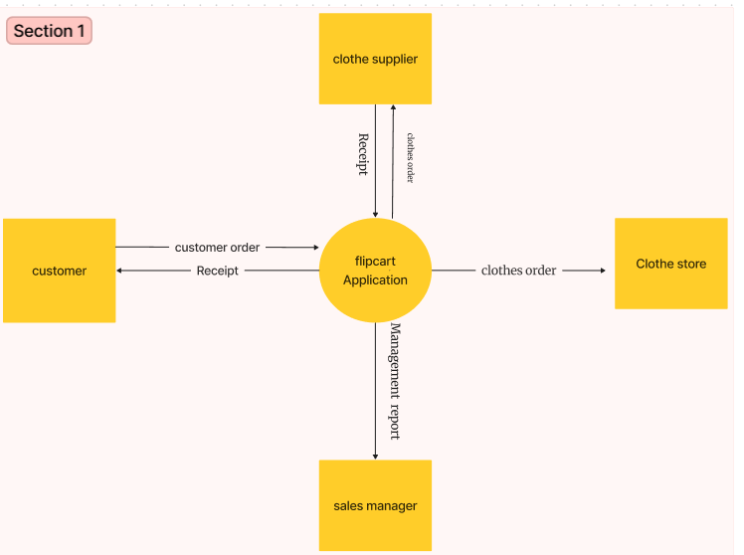

**4.What is Flow chart? Create a flowchart to make addition of two numbers**

A flowchart is a graphic representation of an algorithm or process that uses different forms to stand for distinct activities or steps. A flowchart is a visual representation of a process, with shapes representing different steps and arrows indicating the flow, which can be created using software.

This flowchart shows how to add two numbers:

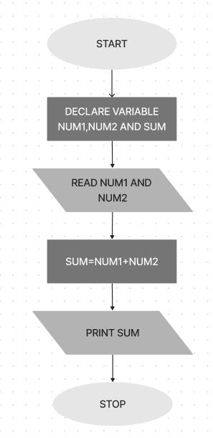

**6.What is Use case Diagram? Create a use-case on bill payment on paytm.**

A use case diagram is a graphic that shows how various actors interact with a system. It shows the functionality that a system offers and the ways in which outside entities communicate with it.

